**Task 1**

**Libraries used:**

* import numpy as np
* from PIL import Image

**For wiki.jpg image,**

* Linear Stretch method is used in the contrast enhancement of the images.

**Main Code:**

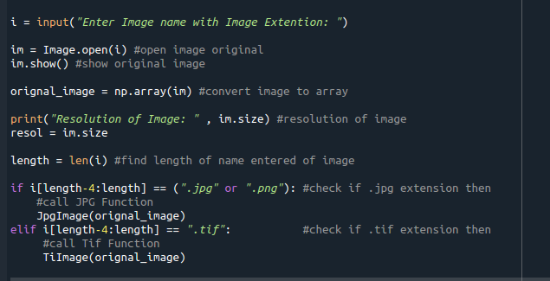

**Jpg Function Code:**

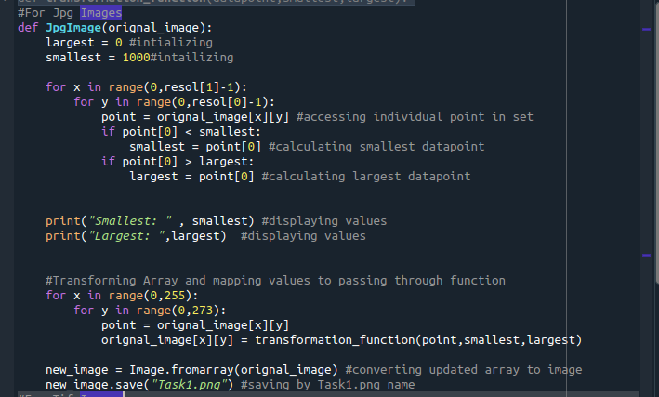

**Original image:**

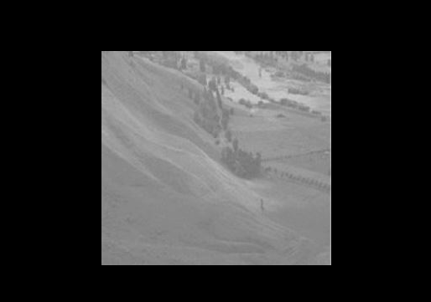

**Improved Contrast Image:**

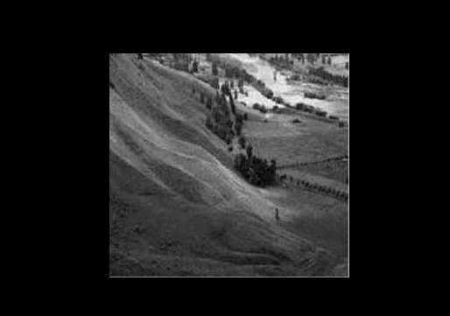

**For lowcon.tif image,**

**Tif Function Code:**

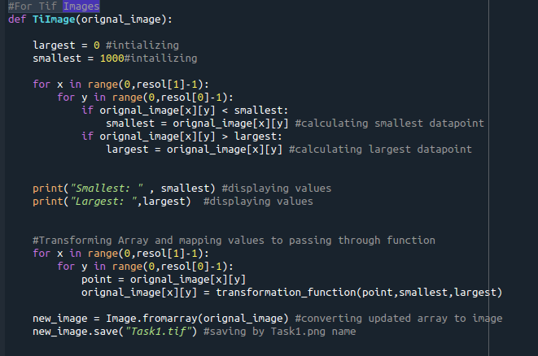

**Original image:**

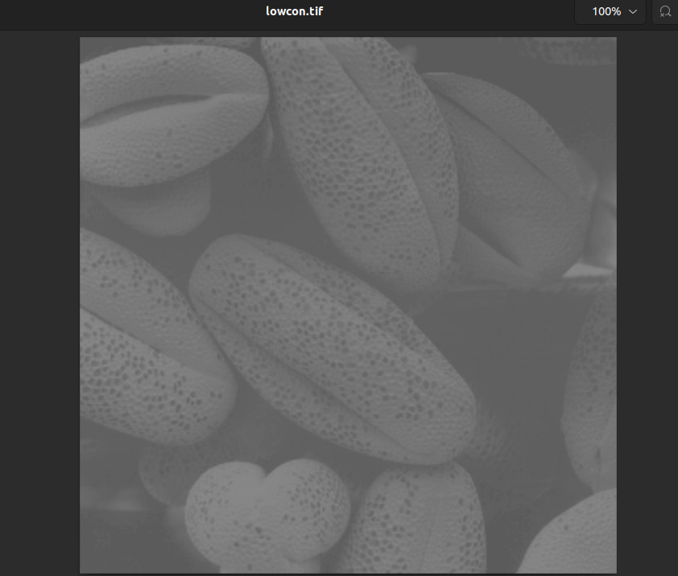

**Improved Contrast Image:**

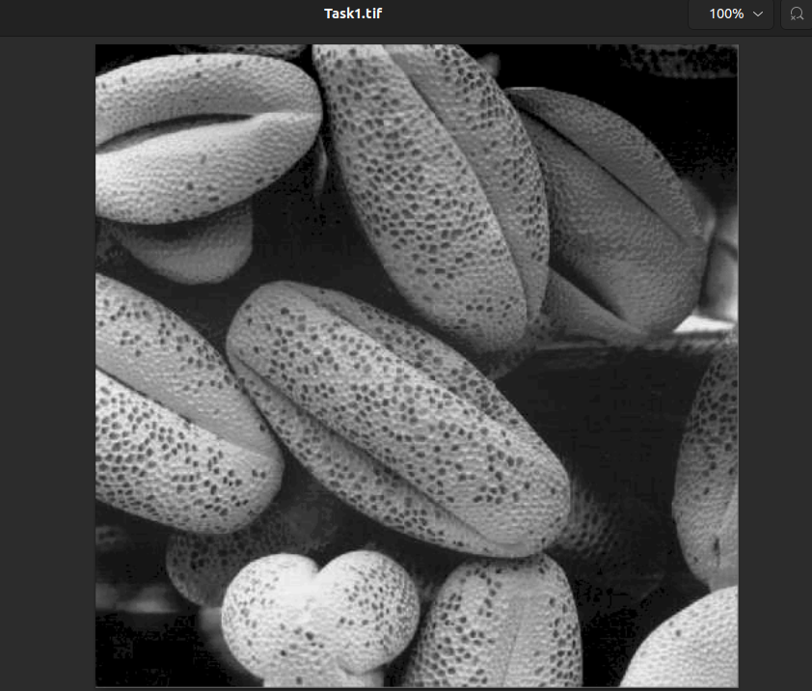

**Transformation Function:**

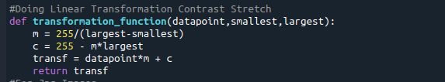

* It calculates the y = mx + c equation of linear stretch.

**Findings:**

* *From the user, the name of the image like “image.jpg” is entered.*
* *After detecting the image’s format, the relevant function is used to enhance contrast.*
* *The transformation function of linear enhancement is used to improve the contrast of the image.*
* *This algorithm works for .jpg, .png and .tif format images.*

Task 2

Main Code:

**from PIL import Image**

**import numpy as np**

**import matplotlib.pyplot as plt**

**import cv2**

**im = Image.open("bright.jpg")**

**im.show()**

**original_image = np.array(im)**

**resolution = im.size**

**print(resolution)**

**frequency = []**

**probability = []**

**transformation = []**

**total_pixels = resolution[0] * resolution[1]**

**frequency = np.zeros(256)**

**probability = np.zeros(256)**

**transformation = np.zeros(256)**

**for x in range(0,resolution[1]-1):**

**for y in range(0,resolution[0]-1):**

**point = original_image[x][y]**

**frequency[point] += 1**

**for x in range(0,resolution[1]-1):**

**for y in range(0,resolution[0]-1):**

**point = original_image[x][y]**

**probability[point] = frequency[point]/total_pixels**

**for x in range(0,255):**

**probability[x+1] = probability[x+1]+probability[x]**

**for x in range(0,resolution[1]-1):**

**for y in range(0,resolution[0]-1):**

**point = original_image[x][y]**

**transformation[point] = probability[point] * 255**

**original_image[x][y] = transformation[point]**

**histr = cv2.calcHist([original_image],[0],None,[256],[0,256])**

**plt.plot(histr)**

**plt.show()**

**For wiki.jpg,**

**Original image:**

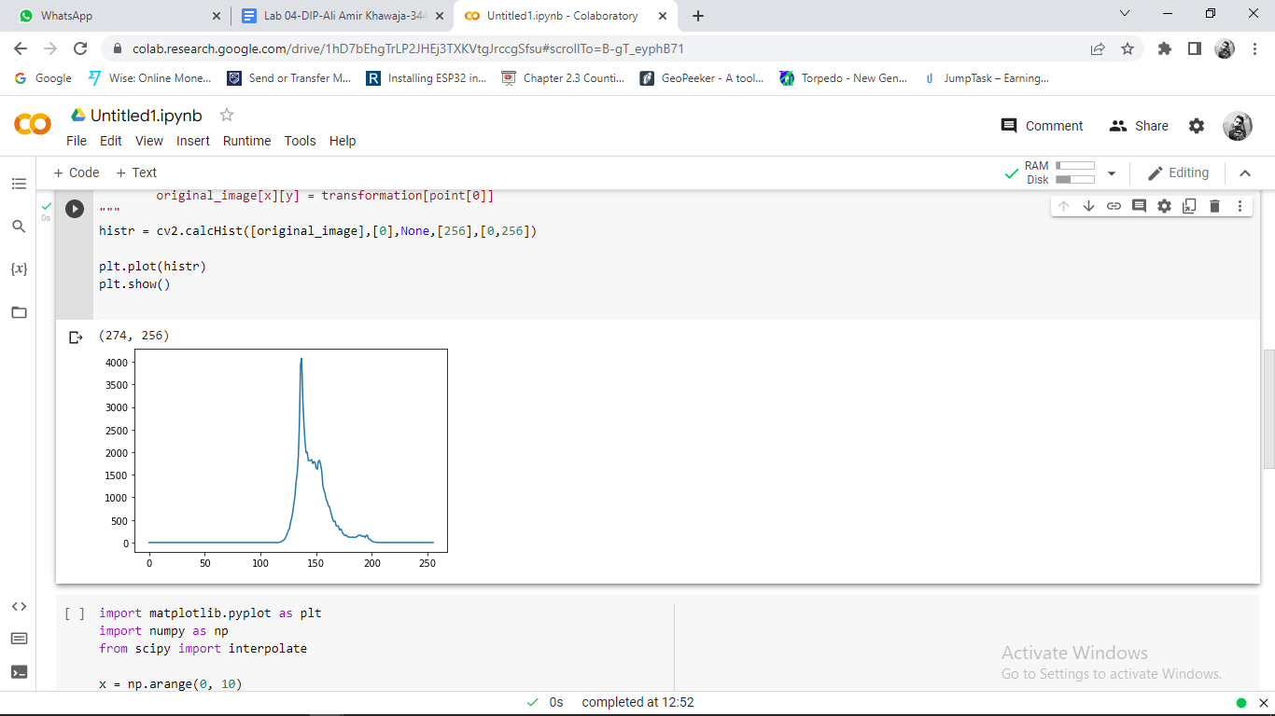

**Improved Contrast Image:**

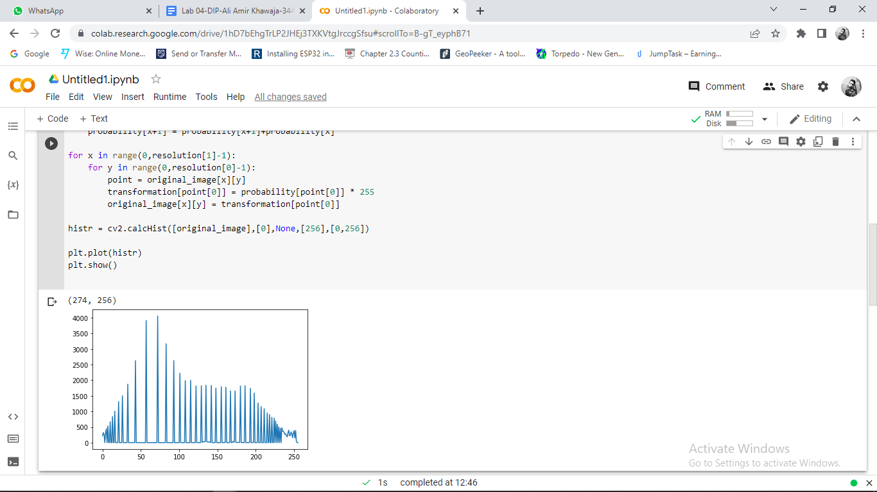

**For lowcon.tif,**

**Original image:**

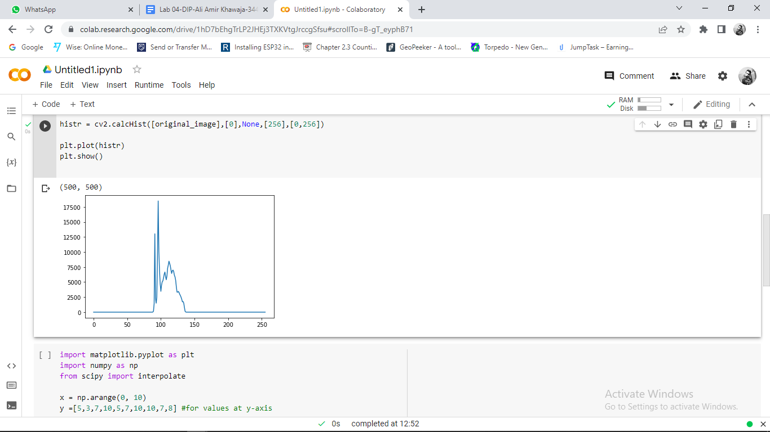

**Improved Contrast Image:**

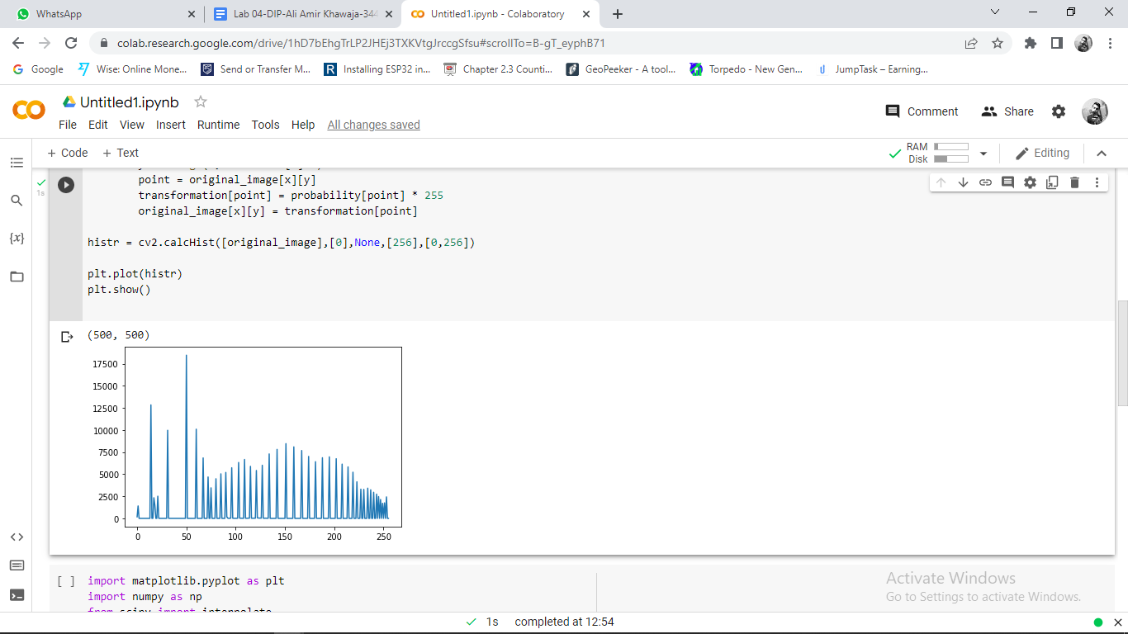

**For dark.tif,**

**Original image:**

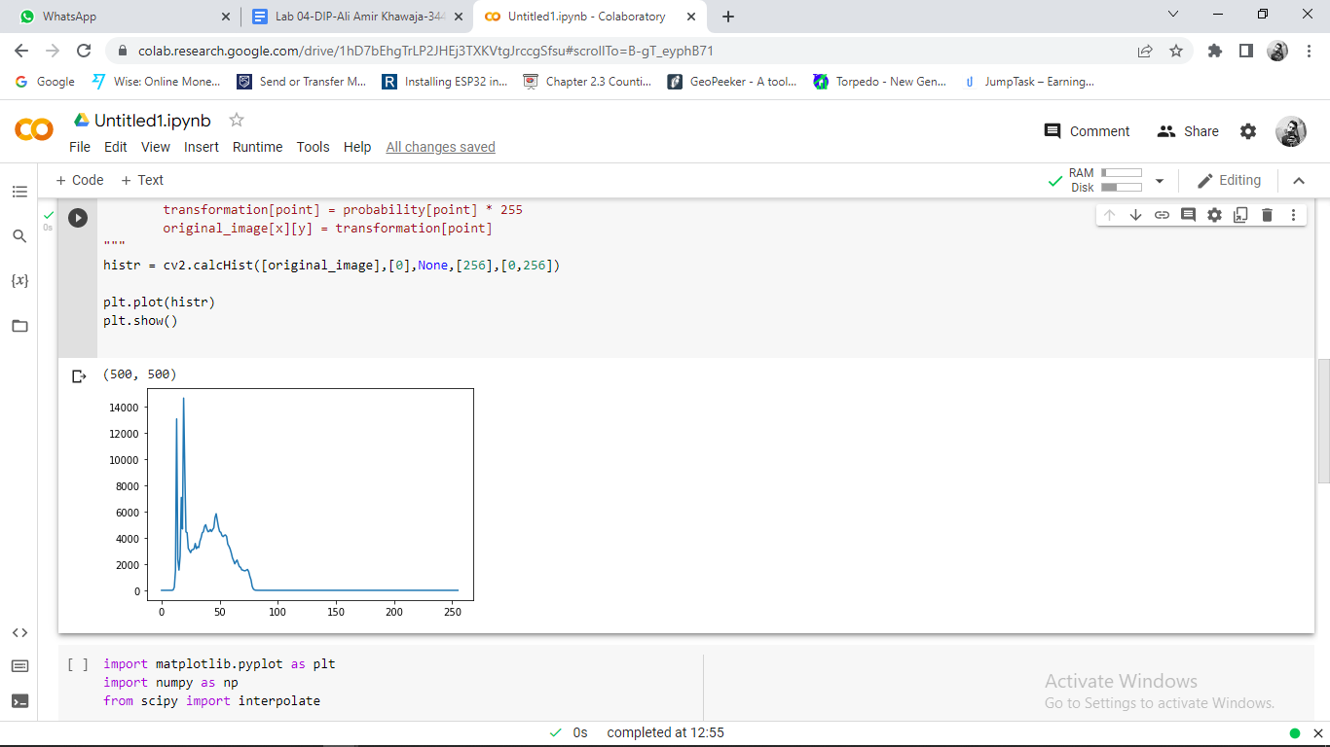

**Improved Contrast Image:**

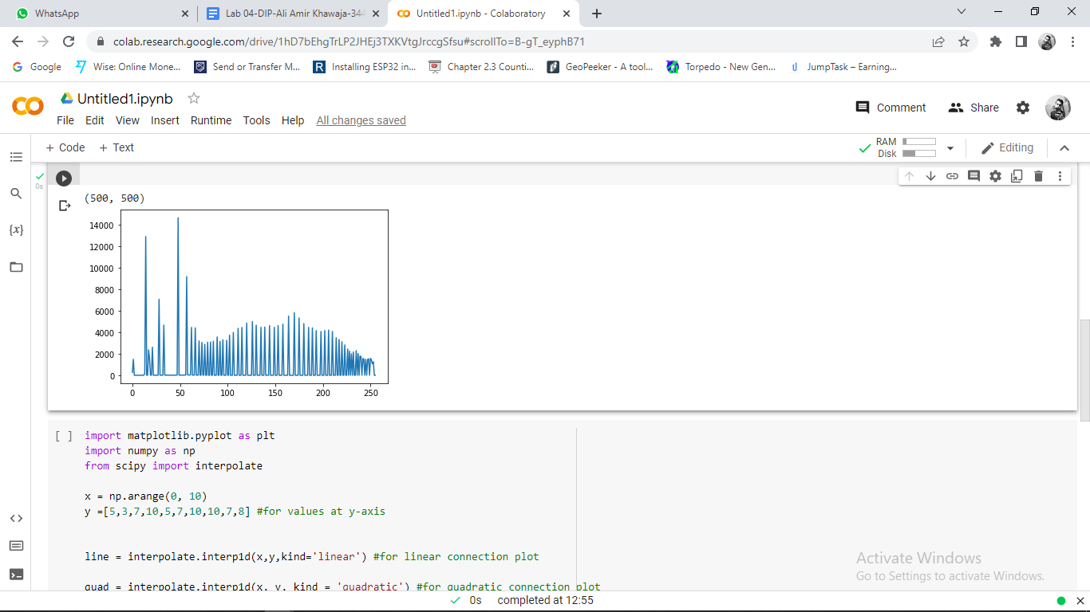

**For bright.tif,**

**Original Image :**

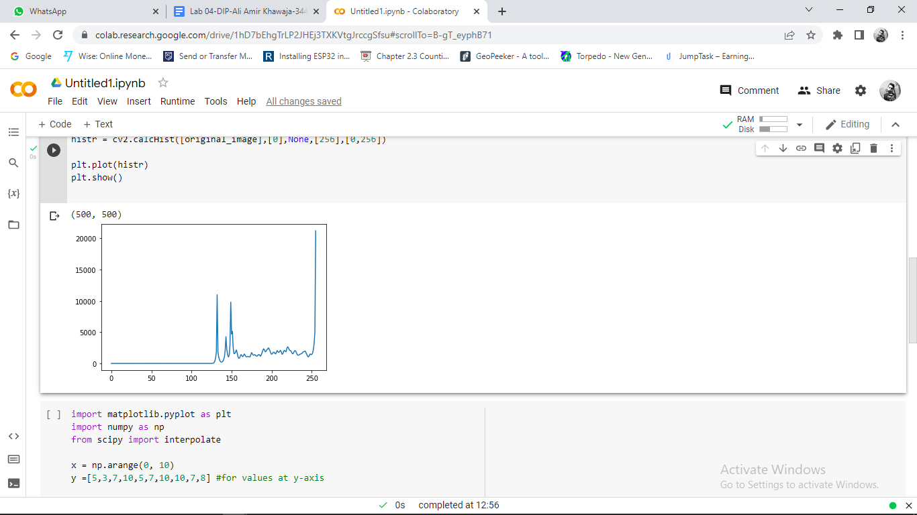

Updated Contrast Image:

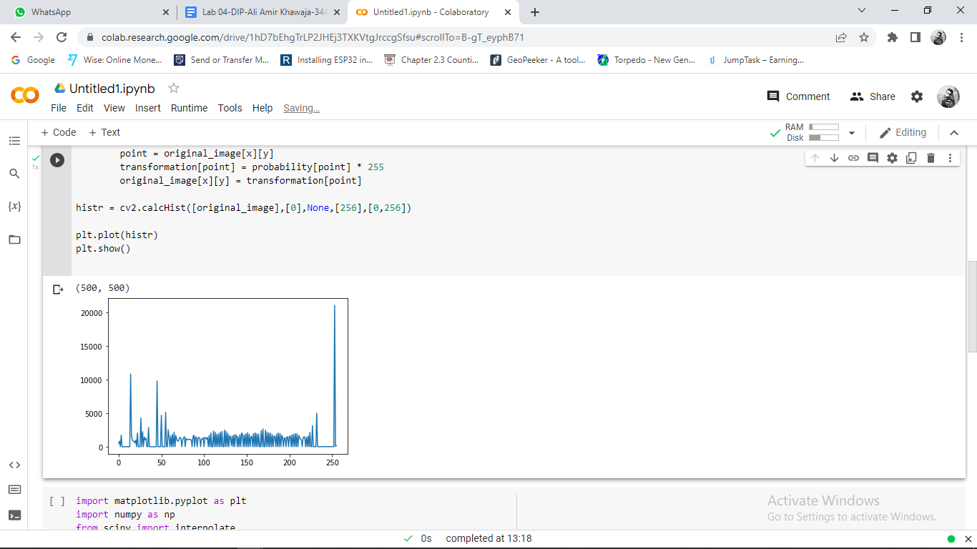

**Findings:**

* For all images all pixels mainly were around in a specific window of values.
* After transformations, the range of the pixels values scattered around a range of values between 0 to 255 color values.